Autophagy signaling in overload-induced skeletal muscle hypertrophy: a comparison between control and type 1 diabetic rats - SUPPLEMENTAL FIGURE S1

Blots used to measure protein changes in expression of p-ULK1 (A), Beclin-1 (B), Atg5 (C), Atg12-5 (D), Atg7 (E), Atg3 (F), LC3-I (G), LC3-II (H) and p62 (I) in contralateral and hypertrophied extensor digitalis longus (EDL) muscles of control and diabetic rats (presented in Figure 4). Gels obtained by western blotting with their respective total protein content (evaluated by Ponceau S) in EDL muscles after 7 days of functional overload. Six animals were used per group. CLC - contralateral muscle of the control group; HC - Hypertrophied muscle of the control group; CLD - Muscle contralateral of the diabetic group; HD - Hypertrophied muscle of the diabetic group.

**B**

**A**

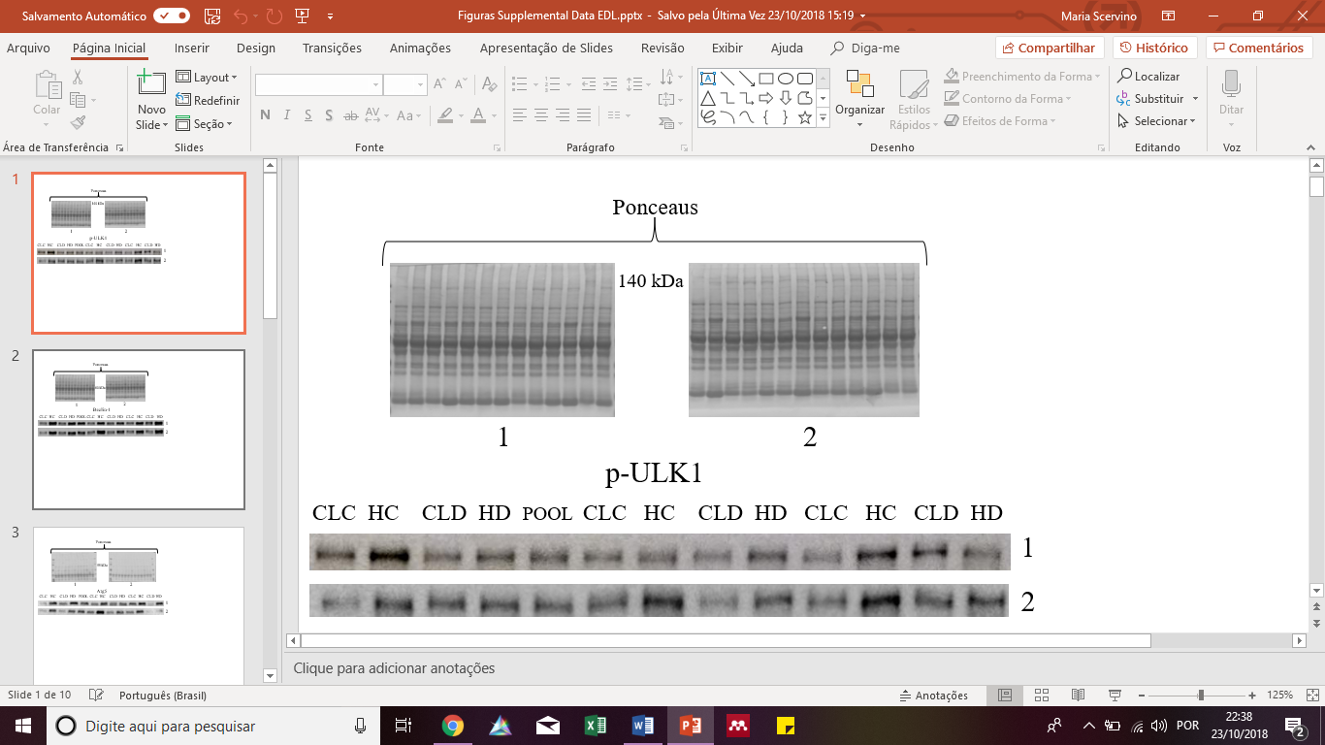 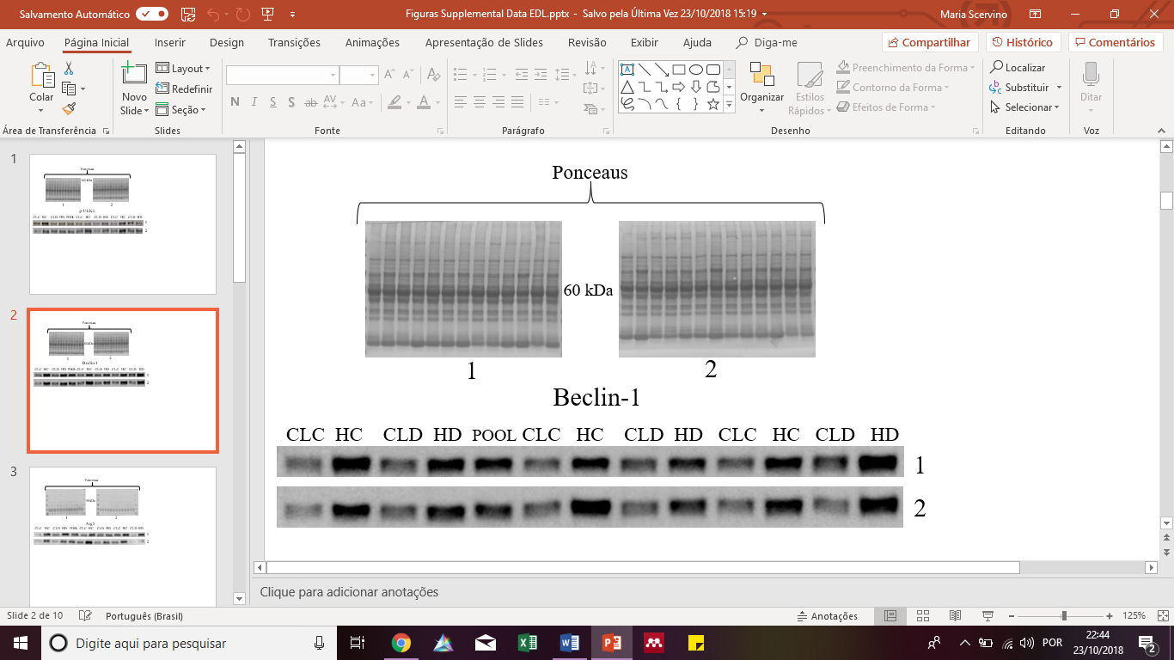

**C**

**D**

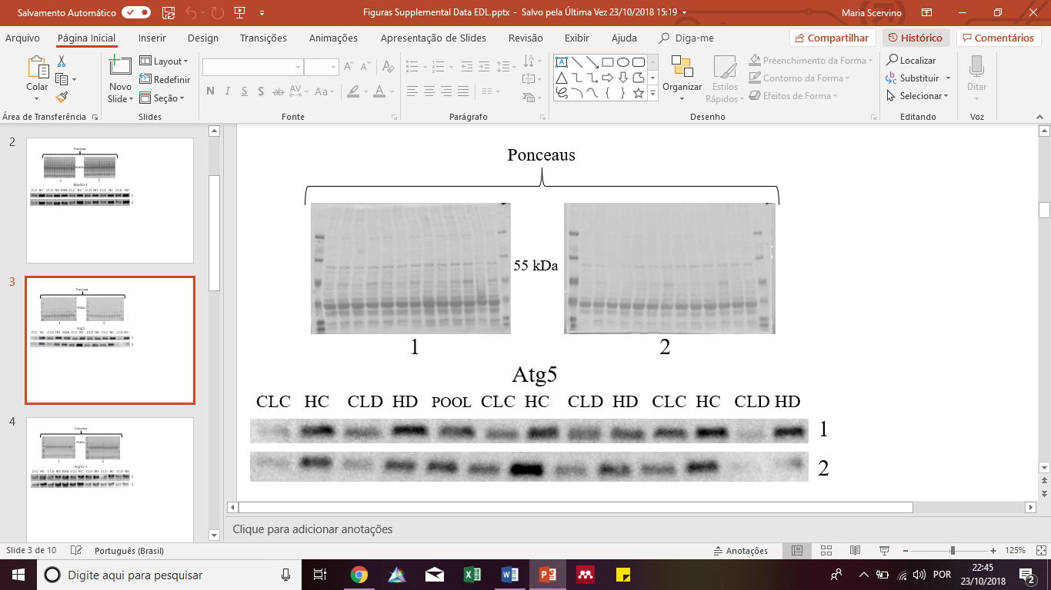 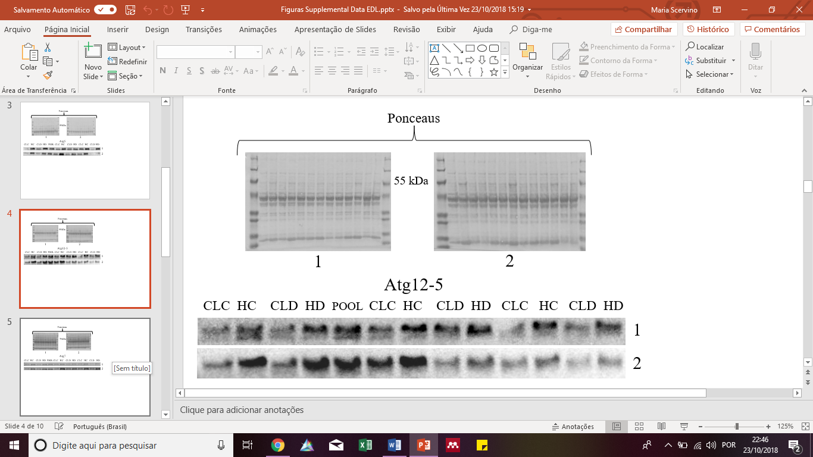

**FD**

**ED**

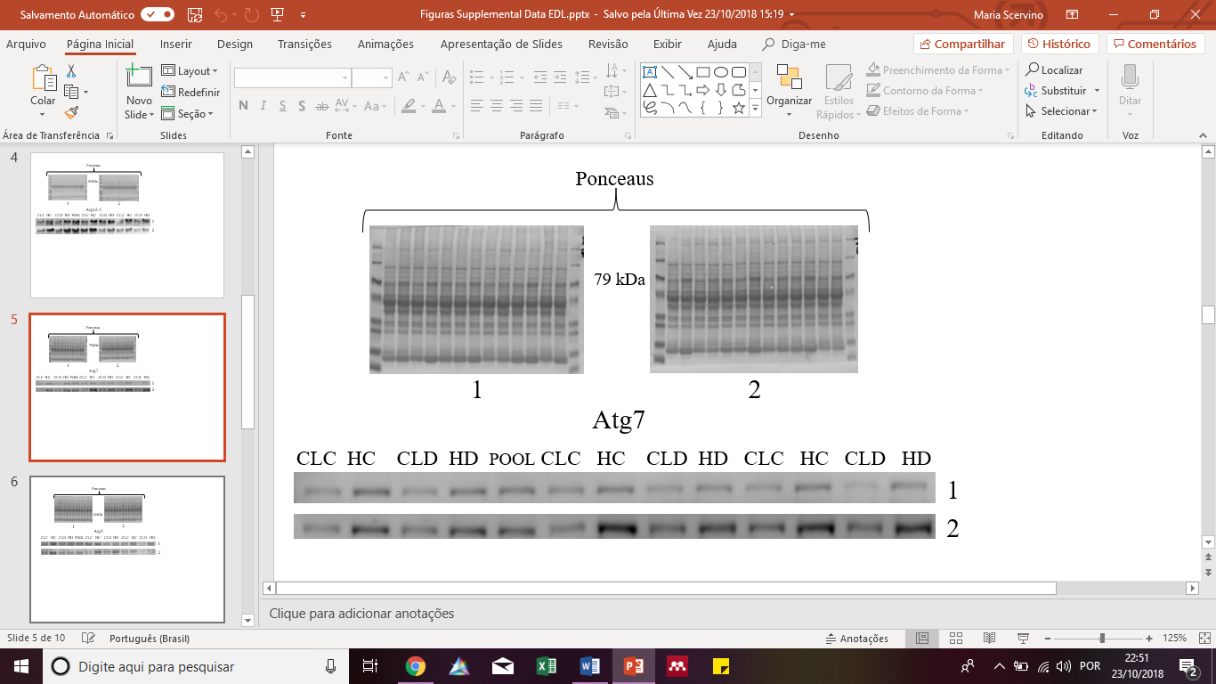 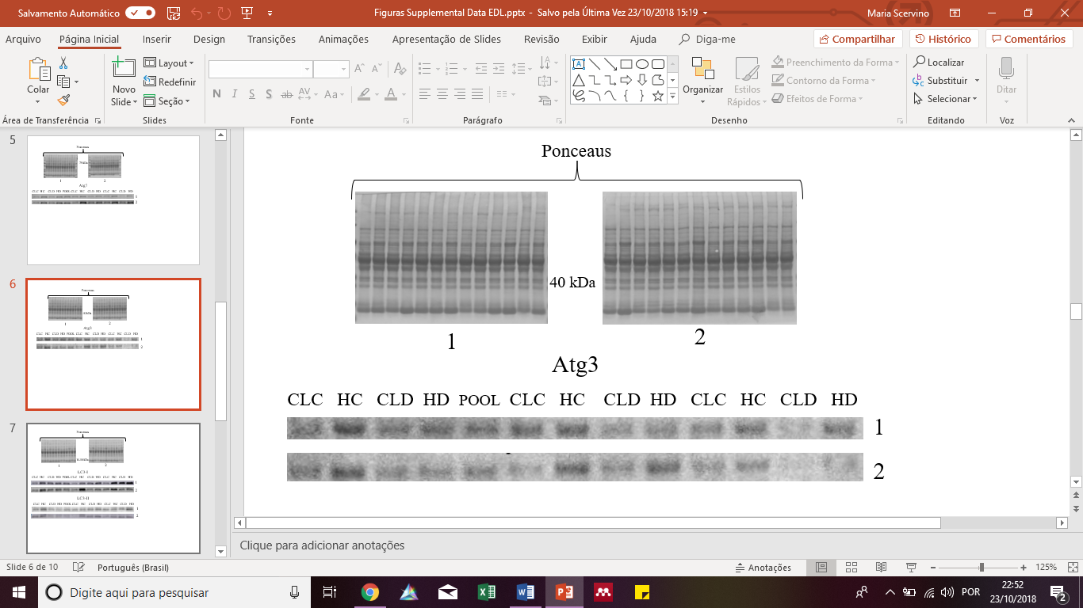

**H**

**G**

